UNIVERSITY INSTITUTE OF COMPUTING

PROJECT REPORT
ON
STUDENT PERFORMANCE ANALYSIS SYSTEM
Subject Name: Python programming
SUBJECT CODE: 25CAH-221

SUBMITED BY:

Name : Kanak Rana UID : 25bcd10104

Branch : BCA(DATA SCIENCE) Group: A Section:25BCD2

Semester : 3

SUBMITED TO:

Name : MS. PREETI D.O.SUBMITION : 22-10-2026

Desigination: A. PROFESSOR
Sign:____________________

Project Report: STUDENT PERFORMANCE ANALYSIS SYSTEM
1. Title
Student Performance Analysis System Using Python and Matplotlib
2. Aim of the Project
The aim of this project is to develop a menu-driven Python application that manages student records, evaluates academic performance, and presents results through graphical visualizations.
The application combines student record management with basic data analysis. It allows users to enter marks and attendance, calculate results, compare performance, and identify students who require additional academic support.
Introduction
Student performance evaluation involves more than calculating total marks. Teachers also need to compare subject performance, identify students with low marks, review attendance, and understand the overall performance of a class.
When these tasks are performed manually, calculations and comparisons can become time-consuming. A computerized application can organize records and produce consistent results using predefined rules.
This project uses Python to store and process student information. Matplotlib is used to display bar charts, a pie chart, a histogram, and a scatter plot. These graphs present the information in a form that is easier to compare and interpret.
The program initially contains six demonstration student records. Users can modify these records or add new students through the menu. Each record contains a roll number, name, marks in three subjects, and attendance percentage.
3. Objectives
The main objectives are:
- To maintain student details using lists and dictionaries.
- To add, view, search, update, and delete records.
- To calculate totals, percentages, grades, and results.
- To rank students according to their percentages.
- To calculate subject-wise and class-wise statistics.
- To identify students needing academic support.
- To highlight attendance below the project threshold.
- To display a dashboard containing six performance graphs.
- To display an individual student’s subject performance.
Scope of the Project
The application is suitable for demonstrating student performance analysis for a small class. It works through a console menu and displays graphs in a separate window.
The current version stores data temporarily in memory. It does not include login facilities, a database, or permanent file storage.
4. Tools and Technologies Used
Python 3
Python is the main programming language used to build the application. It provides functions, loops, conditional statements, and data structures for processing student information.
Matplotlib
Matplotlib is used to create the performance dashboard and individual student graphs. Titles, axis labels, colours, legends, and value labels make the charts easier to understand.
Lists
A list named students stores the student records. Each student’s subject marks are also stored in a list.
Dictionaries
Each student is represented by a dictionary containing the following fields:
Field | Description
roll | Unique student roll number
name | Student name
marks | Math, English, and Science marks
attendance | Attendance percentage
Functions
Functions divide the program into separate operations. This makes the code easier to understand and reduces repeated calculations.
Exception Handling
The program uses try-except to handle non-numeric input. Marks and attendance are accepted only when they are between 0 and 100.
Development Environment
The program can be written and executed using VS Code or IDLE. The environment must support keyboard input and graphical chart windows.
5. System Requirements
Hardware Requirements
- A computer or laptop
- Keyboard and display
- Sufficient memory to run Python and display charts
Software Requirements
- Python 3
- Matplotlib
- VS Code, IDLE, or another suitable Python editor
- A graphical environment for displaying charts
Installation
python -m pip install matplotlib
Execution
Save the source code as main.py and run:
python main.py
Input and Output
The inputs are student details, subject marks, attendance, and menu choices. Outputs include report cards, rankings, class statistics, subject statistics, and graphs.
6. Algorithm / Logic
- Import Matplotlib.
- Create a list containing six demonstration student records.
- Display the main menu.
- Accept the user’s choice.
- Call the function associated with the selected option.
- Validate any new information entered by the user.
- Calculate results or generate graphs as required.
- Return to the menu after completing the operation.
- Repeat until the user selects Exit.
Record Management Logic
Adding a Student
The program checks whether the roll number is blank or already exists. It also checks that the name is not empty. Valid marks and attendance are then accepted, and the record is added to the list.
Searching and Updating
The program searches for the roll number. If a matching record exists, it displays or updates the student information. Results are calculated from the current marks.
Deleting a Student
The program asks for confirmation before removing a matching record.
Result Calculation
Total Marks = Math + English + Science

Percentage = (Total Marks / 300) × 100
A student passes only when the marks in every subject are at least 33.
Condition | Grade
Failed in any subject | F
Passed with 90% or above | A+
Passed with 80% to below 90% | A
Passed with 70% to below 80% | B
Passed with 60% to below 70% | C
Passed with below 60% | D
Analysis Rules
Class Average = Sum of percentages / Number of students

Subject Average = Sum of subject marks / Number of students

Pass Percentage = Passed students / Total students × 100
Students who fail or score below 50% are listed as needing support. Attendance below 75% is highlighted separately. These support thresholds are selected for this project.
7. Code Overview
The program is divided into functions for input validation, record management, calculations, analysis, and visualization.
Input and Calculation Functions
read_number() accepts valid numeric input within a specified range. It repeats the input request when the value is invalid.
percentage() calculates the average of the three subject marks.
result() checks whether every subject mark is at least 33.
grade() assigns a grade using the percentage and pass/fail result.
find_student() searches for a record using its roll number.
Record Management Functions
add_student() creates a new record after validating the input.
report_card() displays marks, total, percentage, grade, result, and attendance.
view_students() displays all records in a tabular console format.
search_student() finds and displays a selected student.
update_student() changes a student’s name, marks, and attendance.
delete_student() removes a record after confirmation.
Analysis Functions
show_ranking() sorts students by percentage in descending order. Equal percentages receive the same rank.
subject_averages() calculates the average marks for each subject.
subject_analysis() displays the average, highest, lowest, and pass/fail counts for each subject.
class_analysis() displays class statistics and identifies students needing support.
Visualization Functions
show_dashboard() creates six graphs in one figure using a two-row, three-column layout.
individual_graph() displays a selected student’s subject marks with a passing-mark reference line.
Main Function
main() displays the menu and calls the selected function. The menu repeats until the user chooses option 11.
Core Calculation Example
def percentage(student):
return sum(student["marks"]) / len(subjects)

def result(student):
if min(student["marks"]) >= 33:
return "Pass"
return "Fail"
8. Screenshots / Output

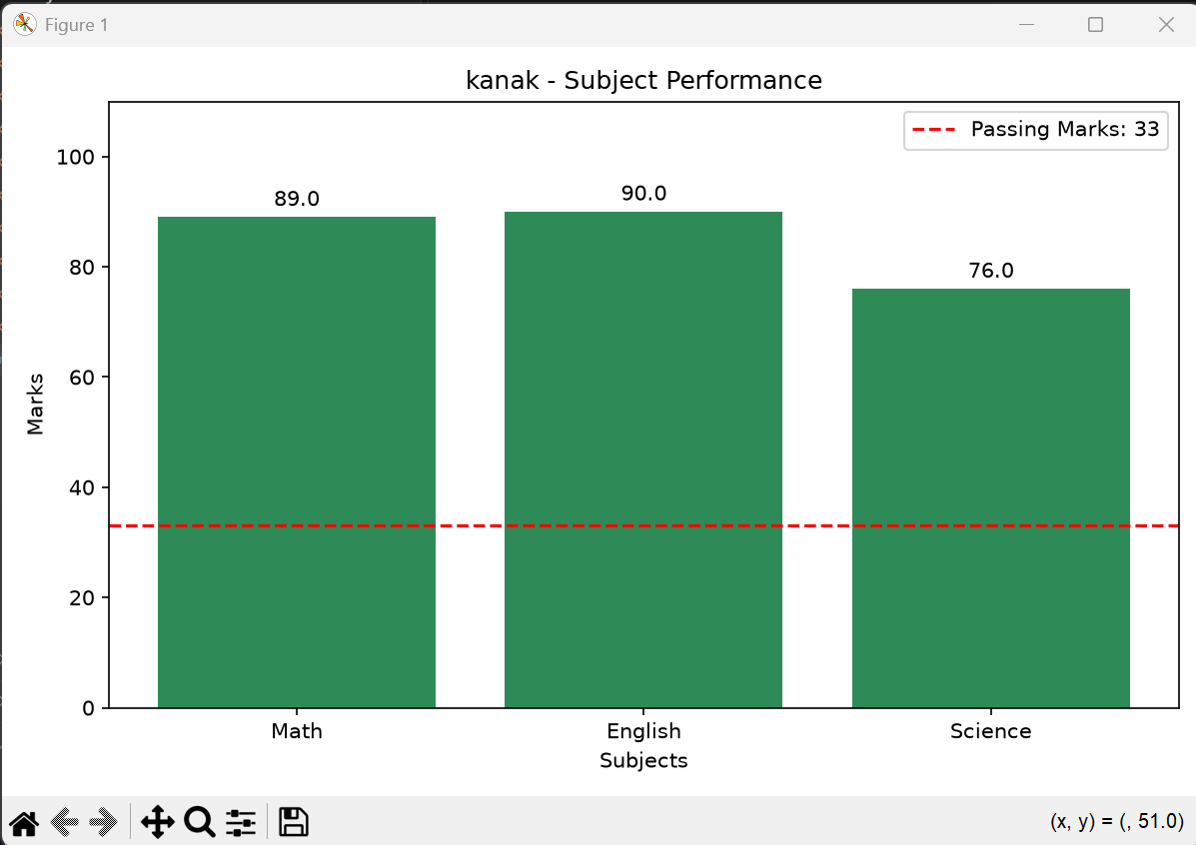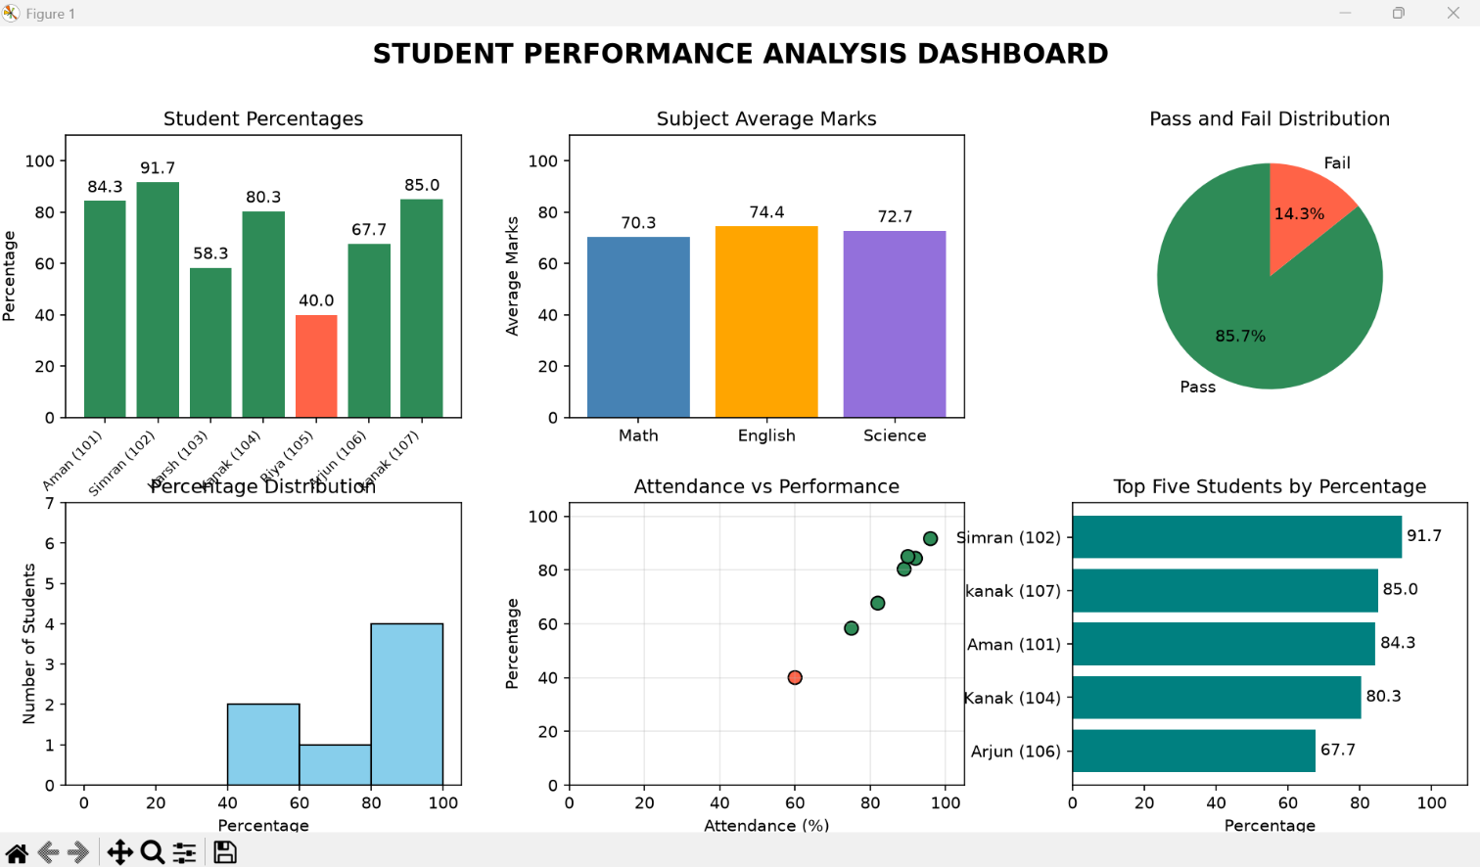
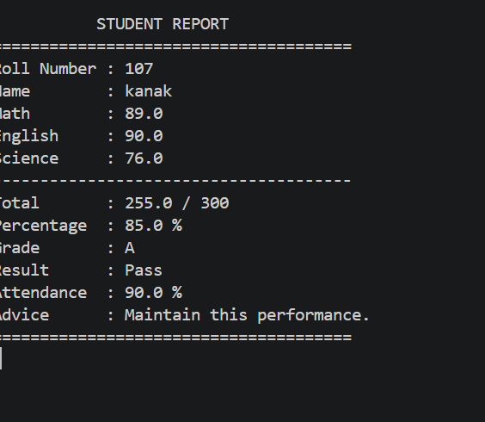

Main Menu
STUDENT PERFORMANCE ANALYSIS

1. Add Student
2. View All Students
3. Search and View Report Card
4. Update Student
5. Delete Student
6. Student Ranking
7. Subject Analysis
8. Class Performance Analysis
9. Performance Dashboard - Six Graphs
10. Individual Student Graph
11. Exit
Performance Dashboard
Sample Student Results
The following results correspond to the initial demonstration records.
Name | Total | Percentage | Grade | Result
Aman | 253 | 84.33% | A | Pass
Simran | 275 | 91.67% | A+ | Pass
Harsh | 175 | 58.33% | D | Pass
Kanak | 241 | 80.33% | A | Pass
Riya | 120 | 40.00% | F | Fail
Arjun | 203 | 67.67% | C | Pass
Class Performance
Total Students : 6
Passed : 5
Failed : 1
Pass Percentage : 83.33%
Class Average : 70.39%
Highest Score : 91.67%
Lowest Score : 40.00%
Subject Performance
Subject | Average | Highest | Lowest
Math | 67.17 | 92 | 30
English | 71.83 | 88 | 48
Science | 72.17 | 95 | 42
Findings
- Simran has the highest percentage at 91.67%.
- Five out of six students pass all three subjects.
- The class average is 70.39%.
- Science has the highest subject average.
- Math has the lowest subject average and requires more attention.
- Riya fails because her Math mark is below 33, despite having an overall percentage of 40%.
- Riya is the only student with attendance below 75%.
- Graphs make differences between students and subjects easier to identify.
Individual Student Analysis
Option 10 displays a student’s subject marks. The passing score of 33 is shown using a reference line. This helps identify the subjects in which the student needs improvement.
9. Conclusion
The Student Performance Analysis System combines student record management, academic calculations, and graphical visualization in a single Python application.
The program allows users to add, search, update, and delete student records. It calculates percentages, grades, results, rankings, and class statistics. The graphical dashboard presents these results in a form that is easier to compare and interpret.
The demonstration results show differences in student performance and subject averages. They also show why overall percentage alone is insufficient for determining whether a student has passed: each subject must meet the minimum passing score.
The application is suitable for a small academic demonstration. Its findings describe only the records entered into the program and should not be generalized to a wider student population.
Limitations and Future Scope
The current version stores records in memory, so changes are lost when the program closes. It also uses only three subjects and does not include authentication.
Future improvements could include:
- Permanent storage using files or a database
- A graphical user interface
- Additional subjects
- Semester-wise performance comparisons
- Exportable student reports
10. Learning Outcomes
Through this project, I learned to:
- Organize records using lists and dictionaries.
- Develop reusable functions.
- Validate input using exception handling.
- Implement searching, updating, and deletion.
- Calculate percentages, averages, grades, and rankings.
- Create and interpret Matplotlib charts.
- Arrange multiple graphs using figures and axes.
- Identify the limitations of temporary storage and sample data.
11. References
- Python Documentation
https://docs.python.org/3/
- Python Data Structures
https://docs.python.org/3/tutorial/datastructures.html
- Matplotlib Documentation
https://matplotlib.org/stable/

